



**Special Educational Needs Policy**

**DOCUMENT STATUS**

|  |  |  |
| --- | --- | --- |
| **Version** | **Date** | **Action** |
| 2023 | 13 March 2024 | Agreed by Governors |
| 2025 |  |  |
|  |  |  |
|  |  |  |
|  |  |  |

**Related Guidance**:

* SEND Code of Practice 0-25
* Equality Act 2010: advice for schools DfE Feb 2013
* Teachers Standards 2012
* Statutory Guidance on Supporting pupils at school with medical conditions April 2014
* Children & Families Act 2014
* The policy on administration of medicine and supporting pupils with specific medical needs
* Safeguarding Policy
* Accessibility Plan

This policy will be monitored and reviewed by the Governing Body in consultation with staff, parents and students.

**SECTION 1**

**Key People**

**The SENCO** is **Miss S. Winter.**

To contact her, please call **0151 228 3772** or email [**hollylodge@hollylodge.liverpool.sch.uk**](mailto:hollylodge@hollylodge.liverpool.sch.uk) The SENCO will respond as soon as possible within normal working hours and in term time.

The SENCO will manage the day to day running of the policy, supported by the SEND Governor, **Miss A Caddick** and the rest of the **Senior Leadership Team.**

**All teachers** are responsible for ensuring that students with SEN are catered for in their classrooms and supporting them in securing the best possible outcomes.

**SEN Mission Statement**

Holly Lodge Girls’ College aims to provide meaningful and effective learning support for students with Special Educational Needs.

We believe in an ethos of high ambition, challenge and support for all of our students. To enable our students to be the best they can be, we follow a graduated approach to SEN support, providing inclusive classroom environments to ensure that students make the best possible progress, despite any difficulties they may face.

We aim to create a safe, caring and supportive setting for students to develop into focused, aspirational and resilient young adults who are well prepared for when they move onto their next phase of education, employment or training.

**SEN Policy Aims & Objectives**:

* To create an inclusive environment that meets the special educational needs of each young person
* To adopt a whole school approach to SEN support where students with SEN are fully integrated into mainstream classes
* To ensure that the special educational needs of children and young people are effectively  identified, assessed and provided for
* To ensure that parents are able to play their part in supporting their child’s education
* To ensure that our young people have a voice in this process and develop skills for life
* To operate a “whole student, whole school” approach to the management and provision of support for special educational needs
* To provide support and advice for all staff working with students with special educational needs

**Identifying Special Educational Needs and Disabilities:**

“A pupil has SEN when their learning difficulty or disability calls for special educational provision, namely provision different from or additional to that normally available to pupils of the same age.” (*SEN Code of Practice, 2015*).

Within the **SEN Code of Practice** there are four main areas of need:

* **Communication and Interaction** 
  + Including difficulties such as speech and language difficulties and Autistic Spectrum Disorder (ASD)
* **Cognition and Learning**

o Including such difficulties as dyslexia, dyscalculia and moderate learning difficulties (MLD)

* **Social, emotional and mental health difficulties** 
  + Including such difficulties as Attention Deficit Hyperactivity Disorder (ADHD)
* **Sensory and/or Physical** 
  + Including such difficulties as hearing impairment (HI) and visual impairment (VI)

At Holly Lodge, we identify the needs of students by considering the needs of the whole child.

High quality teaching, differentiated for individual students, is the first step in supporting students. The quality of teaching is regularly reviewed and is subject to a quality assurance cycle. Staff training is used to further develop the understanding of teachers and their knowledge of how to support all students, including those with SEN.

Some of the following factors that are **not special educational needs** may impact on progress and attainment;

* Attendance and Punctuality
* Health and Welfare
* Having English as an Additional Language
* Being in receipt of Pupil Premium Grant
* Being a Looked After Child
* Being a child of Serviceman/woman

**Identifying Students with Special Educational Needs and Disabilities:**

Information from previous schools is used to identify students with special educational needs prior to them joining year 7 in September. The SENCO and Head of Year 7 meet with staff from Primary Schools in order to gather information on any students with additional needs and ensure that effective plans can be put in place for their transition.

Where a teacher believes that a student they teach has SEN, they can refer them to the SENCO for additional investigation. The primary way that students are supported is through high quality teaching in the normal classroom setting, and so staff will already have trialled various methods of effective differentiation to support the student.

Where a parent believes that their child has SEN, they can contact the SENCO to arrange a meeting. Information from class teachers and pastoral staff will have been gathered to inform the meeting.

**Providing SEN Support:**

Holly Lodge follows a graduated approach to providing support for each child, as shown on the windscreen below.

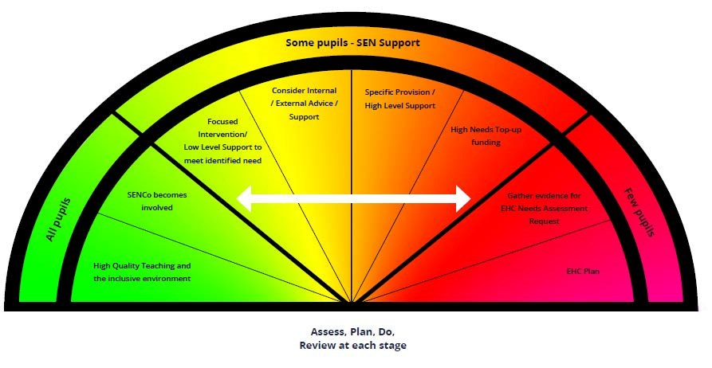

* In deciding whether to place a student on the SEN register, information is gathered for each student. Student progress will be looked at, alongside national data and expectations of progress.
* Teachers are responsible and accountable for the progress and development of all students in their class, including where students access support from teaching assistants or specialist staff.
* High quality teaching, differentiated for individual students, is the first step in responding to students who have or may have SEN. Additional intervention and support cannot compensate for a lack of good quality teaching.
* As part of our Teaching and Learning quality assurance cycle, the teaching in the school is reviewed regularly, through a variety of methods. Where teaching is found to be less than good, support plans are put in place to help staff improve their teaching.
* The SENCO will deliver and/or co-ordinate staff training on ways to support students with SEN.
* Underachieving students are identified at regular intervals throughout the year and they may form part of our whole school mentoring system.
* For higher levels of need, external agencies and professionals can be contacted for specialist assessments or support. We follow the ‘**Assess-Plan-Do-Review’** model of support in line with the SEND Code of Practice.

**Students with Social, Emotional and Mental Health Difficulties:**

Students with social, emotional and mental health difficulties may be identified by the Pastoral Team. The School’s pastoral team will in general have oversight of this group of students’ progress.

Advice will be available from the SENCO. Heads of Year will normally contact parents / EWO / Learning Support Mentors.

**Involvement of parents & families**

Students identified as having special educational needs have a pupil profile detailing their area/s of difficulty and providing strategies to support them in school. These are updated in consultation with parents and students 3 times a year. Parents are able to request to meet with the SENCO between review periods if necessary.

A Transition Forum takes place in June when Miss Winter meets SENCOs from primary schools to discuss the needs of students who will be transferring to our school. Written information is received for students with Special Educational Needs or who are deemed vulnerable. Appropriate SEN Support and strategies can then be put in place for new Year 7 students.

Detailed information is provided to all staff, prior to the new academic year in September. Students with special educational needs have a pupil profile, which can be accessed by each of their teachers. Parents of students with SEN are able to meet with the SENCO in the summer term or once their child joins Holly Lodge to discuss their needs and how they will be supported.

**Managing Student Needs on the SEN Register**

Interventions and support strategies are devised in accordance with identified need and information from relevant sources.

SEN support takes the form of a 4 part cycle through which earlier decisions and actions are revisited, refined and revised with a growing understanding of the student’s needs and of how the student is best supported in making good progress and securing good outcomes. This cycle is known as the graduated approach (assess, plan, do, review):

Assess



Plan



Do



Review



All students are monitored each term, through regular internal assessment tasks and tests. Parents receive three reports each year and are also invited to Parents’ Evenings. Students who have special educational needs will have a Pupil Profile, which outlines their strengths, difficulties and suggests strategies to support them. An overall Provision Map also details SEN Support for each year group. These are reviewed every term by the SENCO or if the needs of students change.

**Examples of Support Strategies:**

* ICT programmes such as Lexia may be used in lessons to help support a student.
* They may have extra literacy sessions to improve their basic skills.
* They may have access to a Teaching Assistant in some lessons.
* Students who struggle with writing may be provided with a mini laptop/electronic notebook, which they can use when written tasks are required in their lessons. They may need extra time and/or reading support for examinations, which will be provided when necessary.
* Students with social or emotional needs may have a Learning Mentor, ELSA intervention and/or a time out pass to help them to manage their behaviour more effectively.
* External agencies may be involved to help devise support strategies for some students.

**SEN Support is regularly reviewed and modified to meet the needs of students.**

**Education Health Care Plans (EHCP):**

Some students have an Education Health Care Plan. These students will have high levels of need and therefore require additional support. **Only few students require this level of support**, and only once in-class interventions and support strategies have been implemented and reviewed. EHCPs require a formal Annual Review, where targets and outcomes are revisited and set for the following year. These reviews will always be person centred with the student at the centre. The plan will determine the support provided.

**Withdrawing SEN Support:**

**SEN** supportin school **will stop** if a student makes or exceeds expected progress and no longer requires support additional to or different from their peers. Parents and students will be consulted before a decision is made.

**Supporting students and families:**

The Local Authority holds questions and answers related to SEN, for every school in the city. A Local Offer is published that details support available in the city for families and young people with SEN.

**Exam Access Arrangements** assessments take place in Year 10. Students are assessed using standardised tests to determine whether they qualify for exam access arrangements. All arrangements must reflect a students’ normal way of working throughout their time at school. Evidence is gathered on a regular basis in order to support these applications. Students who have used a word processor during their time at Holly Lodge, **as their normal way of working**, will be allowed to use this for exams.

The school has a statutory requirement to provide an SEN information report (regulation 51, Part 3, section 69(3)(a) of the Act). We (the school) will signpost information regarding the Local authority’s local offer as well as any additional agencies which may assist or support the family and student.

**Medical Conditions**

The school recognises that students with medical conditions should be properly supported so that they have full access to education, including school trips and physical education. Some children with medical conditions may be disabled and where this is the case the school will comply with its duties under the Equality Act 2010.

Some may also have Special Educational Needs and / or Disabilities (SEND) and may have an Education, Health and Care plan (EHCP) and the SEND Code of Practice (2014) will be followed.

**Monitoring and Evaluation of SEN**

The quality of provision for students is regularly reviewed by the SENCO. Support is provision mapped to monitor impacts and all interventions delivered by Learning Support are closely monitored.

Departmental audits are carried out with regard to provision for students with SEN across the curriculum. Work scrutiny, drop-ins, learning walks and lesson observations also help to monitor provision for students with SEN.

Should you wish to raise any issues, you can contact the SENCO by email or telephone at any time.

**Training and Resources**

Resources for SEN are funded from the school’s budget. The SENCO is responsible for purchasing training and resources specifically to support students with SEN.

In order to maintain and develop the quality of teaching and provision to respond to the strengths and needs of all students, all staff are encouraged to undertake training and development.

The school’s SENCO regularly attends the LA’s SEN briefings in order to keep up to date with local and national updates in SEND, and shares information with staff from any courses/meetings related to SEND.

**Roles and Responsibilities**

* The Headteacher is Mr Andrew Keen
* SEN provision within the school is coordinated by the SENCO, Miss Sarah Winter
* A team of (HL)TAs support the most vulnerable learners across the curriculum.
* Mrs Faye McDermott is the DSL.
* The management of PPG/LAC funding is organised by the School’s Business Manager.

**Complaints Procedure**

From time to time problems arise in any organisation. Although Holly Lodge tries very hard to ensure that all its policies are carried out efficiently and effectively, we appreciate being informed if something is not being done properly.

**Useful Links:**

[Liverpool Local Offer](http://fsd.liverpool.gov.uk/kb5/liverpool/fsd/localoffer.page?familychannel=10)

[SEND Code of Practice](https://www.gov.uk/government/publications/send-code-of-practice-0-to-25)

[Holly Lodge SEN Information](https://www.hollylodge.liverpool.sch.uk/statutory/policies/)

[Holly Lodge Accessibility Policy](https://www.hollylodge.liverpool.sch.uk/statutory/policies/)