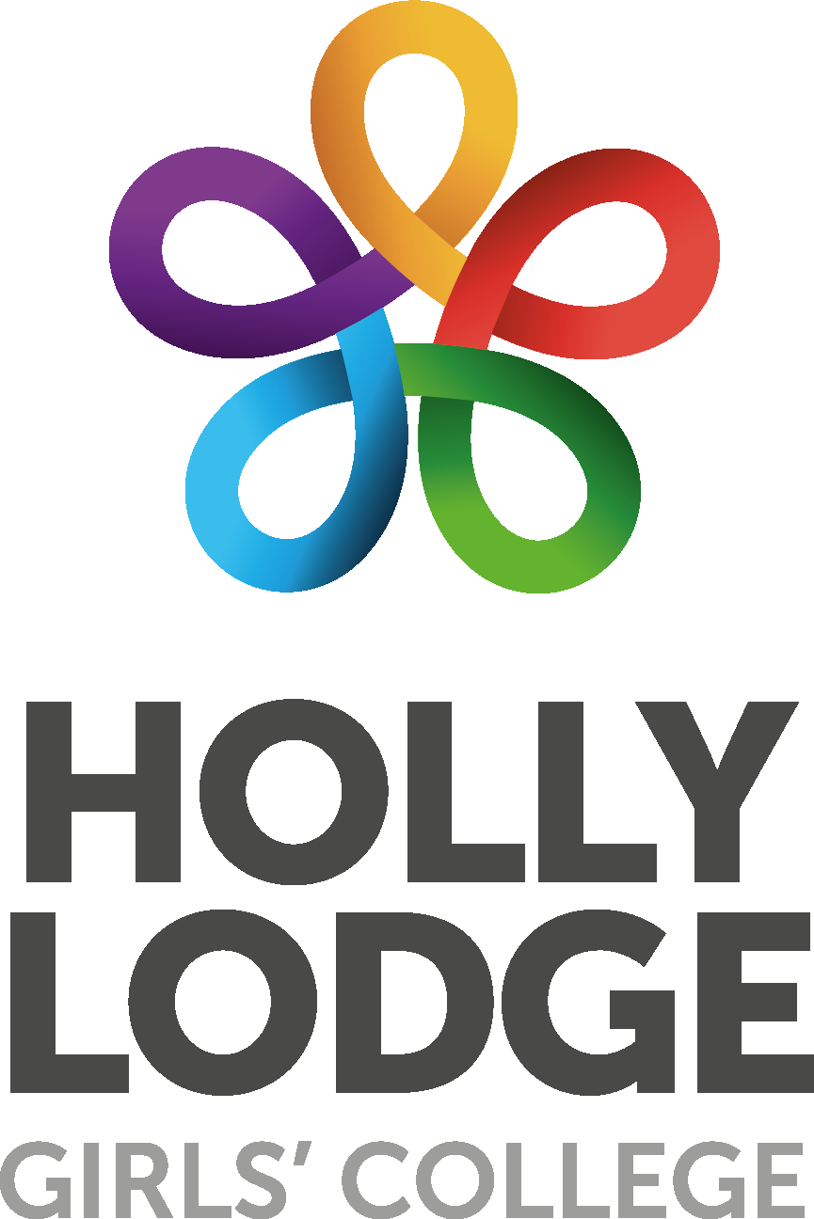

SEN Information Report 2023

Key People
Miss S. Winter | SENCO
Miss R. Rivers | SEND Team Manager
Vacancy | Assistant SENCO
Mrs C. Murphy  Ms S. Read | Higher Level Teaching Assistants  English  Maths
Mrs S. Hatchard | Emotional Literacy Support Assistant
Mrs K. Hutton  Miss C. Bartsch  Miss C. Mundle  Miss M. Abdelghani | Learning Support Assistants
Ms A. Caddick | SEN Governor

To contact Learning Support, please call 0151 228 3772 or email hollylodge@hollylodge.liverpool.sch.uk. The SENCO or Assistant SENCO will respond as soon as possible within normal working hours and in term time.
___________________________________________________________________________
SEN(D) INFORMATION ANNUAL REPORT
Children with special educational needs have learning difficulties or disabilities that make it harder for them to learn than most children of the same age. Their difficulties may be related to;
- Communication and Interaction
- Cognition and Learning
- Social, emotional and mental health difficulties
- Sensory and/or Physical Needs
In Holly Lodge we identify the needs of students by considering the needs of the whole child.
These students may need support that is additional to and different from the support provided by other students of the same age.

The Special Educational Needs Code of Practice 2015 lies at the heart of our school’s SEN Policy and sets out the processes and procedures that all organisations should follow to meet the needs of children.
Holly Lodge Girls’ College follows a graduated approach to SEN support, with high quality teaching as the central focus. An assess, plan, do, review cycle is followed in ensuring support is meaningful and effective.

Special Educational Needs

Support for students with special educational needs falls into four broad areas, as detailed below. All provision over the academic year has been implemented with due regard to restrictions in place due to Covid-19. Support has been adapted to comply with social distancing protocol. In rare cases where this has not been possible, a small number of interventions have had to be suspended and alternative support measures put in place for students.

- Communication & Interaction
  - The Learning Support Department runs several social communication interventions, including Lego Therapy and Talkabout. We also have two members of staff trained as Emotional Literacy Support Assistants who provide 1:1 intervention and support to select students.
  - For some students, daily 1:1 check ins are in place with a member of the Learning Support team. These enable them to discuss any specific issues they may have and provide them with strategies to deal with them.
  - Some students access the Learning Resource Centre at break and lunch times. Some students also access support from the Sensory Service within school hours. For students with sensory issues, specific strategies such as early movement between lessons and time out passes may be used.
- Cognition & Learning
  - There are a number of specific interventions for students, including literacy and numeracy interventions outside of regular classes. Intervention programmes used include Catch Up Literacy and Catch Up Numeracy, Talisman, Magic Belt and Lifeboats.
  - Students are also supported via the use of ICT, with some students using laptops for extended writing.
  - Students with specific learning difficulties are provided with necessary equipment to support them in lessons, such as reading rulers or handwriting pens.
  - Some students benefit from having TA support in their lessons.
  - Students in years 7-9 who have been identified as needing support with literacy skills have been enrolled on MyLexia to enable independent work to be carried out in order to develop these key skills
- Social, Emotional & Mental Health
  - Students are supported through our strong pastoral system. We also have three Learning Mentors who specific students are attached to to provide additional support.
  - Some students access therapeutic interventions such as Drawing and Talking and ELSA via Learning Support.
  - For students who struggle in the classroom setting, an EXIT card may have been issued and/or early movement between lessons be permitted.
  - There are also monthly drop-ins provided by YPAS within school, or staff can refer students to YPAS or CAMHS at parental request.
- Sensory and/or Physical needs
  - These needs are catered for on an individual basis, taking into account student and parent voice. External agencies such as the Sensory Service are usually involved in ensuring appropriate support is developed.

Students with SEN are supported through a graduated approach:

STAGE 1: A student with an additional need, supported primarily through in-class differentiation and Quality First Teaching. Some of these students may also benefit from in-school support and interventions delivered by the Learning Support Department.

STAGE 2: A student with additional needs, targeted by the Learning Support Department to receive additional support. They may receive support from other agencies. They will be likely to receive in-school interventions and are more likely to have a Learning Support Assistant (LSA) in their classes than other students.

STAGE 3: A student with an EHCP who receive a high level of support. Specific support is determined by the outcomes described in their EHCP, and is evaluated as part of the Annual Review process.

Reasonable adjustments to the curriculum and/or school environment are considered on a case by case basis and agreed in consultation with the school, parent/s and child.
Where necessary, top up funding required in order to secure necessary support for an individual student may be applied for. This takes place in consultation with the parent/s and child.

Our LSA’s support a range of students, helping them to access the curriculum and together with their teachers, ensure they make the best possible progress in a safe, caring and supportive environment.

We also have three Learning Support Mentors (Lisa Harland, Angie Martin and Faye McDermott) offering emotional, behavioural and pastoral support whenever it is needed.

External Agencies

The school accesses some support from external agencies to assist in meeting the needs of our students.

The following agencies continue to support SEN students, as required, throughout the year
- Educational Psychologist
- Speech and Language Therapy Service
- Alder Hey Physiotherapy Service
- Community Paediatricians
- Education Welfare Service
- School Nurse
- Child and Adolescent Mental Health Service (CAMHS)
- Young Person’s Advisory Service (YPAS)
- Sensory Impaired Service

Liaison with School Partners
Strong links exist with our local primary schools. Mrs Rhodes, Primary Liaison Officer, works closely with primary schools throughout the academic year in order to ensure smooth transition to secondary school. A Transition Forum takes place in the summer term, to ensure accurate and efficient transfer of records and information in order to support students transferring to secondary schools. Additional transition and induction visits are set up for students with SEN where required so that they can familiarise themselves with the school site and alleviate any concerns they may have ahead of joining in September. Holly Lodge also runs Enhanced Transition days for students and parents of students who are vulnerable or who have additional needs. Where possible, either the SENCO or a member of the pastoral team will attend any EHAT or EHCP review meetings they have been invited to in the summer term.

For students moving onto other post-16 destinations, Holly Lodge is happy to facilitate familiarisation visits ahead of the transition, and to communicate advice and support strategies that have been tried and tested.

Staff Development

Staff receive continued professional development in supporting students with SEN in the classroom on a regular basis as part of Holly Lodge’s INSET and twilight training programme, as well as receiving bespoke information, advice and guidance from the SENCO and outside agencies as required. Staff have access to the National College where training on a wide variety of areas is readily available. In addition, teaching assistants also benefit from regular training to update and develop their skills and enable them to deliver specific interventions.

Current Cohort

As of January 2023, we have 151 students receiving some form of SEN support.

They are currently broken down into the following primary needs and national curriculum years:

Attainment of Students

The progress of students is assessed regularly with formal examination weeks calendared during the year, alongside national data and expectations of progress. Students and parents are always involved in discussions about progress. Interventions are constantly reviewed and further support put in place.

Interventions may include: Support from Learning Support Assistants, Learning Mentors, extra Literacy sessions, extra Numeracy sessions, ICT Resources including use of a laptop, Homework Support, extra-curricular access to specialist resources or exam access arrangements. Where students have had additional out of class interventions, their progress is monitored over the course of the intervention and fed back to class teachers so that they can embed the skills developed.

Parent Communication

Parents and Carers are regularly updated on their children’s progress with progress reports and parents evenings. Pupil profiles for SEN students are reviewed in line with these reports, and parents and students are invited to make contributions to these. Parents can also arrange to meet with Miss Winter on request at any point throughout the year.

Disability & Accessibility

Under the Disability Equality Duty schools are required to take proactive steps to ensure their disabled students, staff and governors, parents / carers and other people using the school are treated equally. Schools are required to establish a Disability Scheme to promote equality of opportunity for disabled students. The goal is to improve access to facilities and the physical environment of the school, as well as access to the curriculum and information for students. The school’s Accessibility Plan is available on the school website.

The school takes reasonable steps to prevent disabled students from being treated less favourably than other students. For example:
- A Learning Support Assistant/designated person may accompany children on visits.
- Disabled toilets
- Range of resources offered to support individual needs e.g coloured overlays, laptops, ICT programs.
- The LRC is a quiet area, where students can have access to computers and a printer, or have access to a quiet area to read at break times and lunch times if they do not wish to be on the yard.
- Exit Cards/Time Out Cards
- Passes to leave lessons early to go to next lesson to avoid congestion in corridors
- Wheelchair and Lift access
- Inclusive ethos of our school where every student is treated as an individual.
- Adaptations to the curriculum will be made where necessary and students will be supported as they move between each phase of their education, involving appropriate experts from outside agencies as required.

Please do not hesitate to contact our SENCO, Miss Winter on 0151 228 3772 if you have any queries relating to the information contained within this report.

Complaints Procedure
From time to time problems arise in any organisation. Although Holly Lodge tries very hard to ensure that all its policies are carried out efficiently and effectively, we appreciate being informed if something is not being done properly.

Click here to view a copy of our complaints procedure.

Acronyms

SENCO: Special Educational Needs Coordinator
HLTA: Higher Level Teaching Assistant
LSA: Learning Support Assistant

SENISS: Special Educational Needs Inclusion Support Service
YPAS: Young Person’s Advisory Service
CAMHS: Child and Adolescent Mental Health Service
EHCP: Education Health Care Plan
LRC: Learning Resource Centre

Key Information

Liverpool Local Offer
Local Authority SEN Team
Holly Lodge SEN Policy
Holly Lodge Accessibility Plan

