

**BTEC LEVEL 3 NATIONAL EXTENDED CERTIFICATE**

**Unit 1- Learning Aim A**

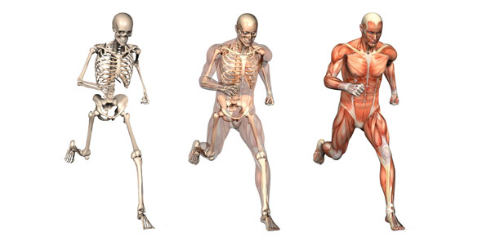

**STUDENT SUMMER PROJECT BOOKLET**

**STUDENT NAME: __________________________**

**SKELETAL SYSTEM**

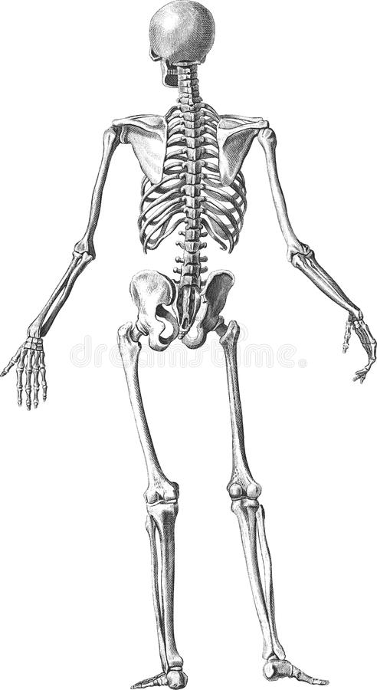How many bones can you remember?

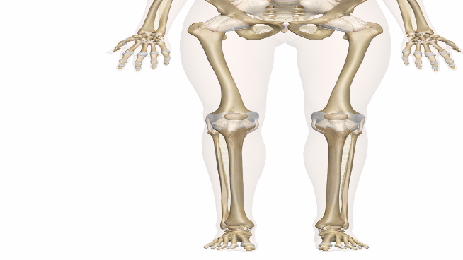

Label the major bones on the diagram below:



|  |  |  |
| --- | --- | --- |
|  | | **Complete** |
| **Major Bones:** | Cranium |  |
| Clavicle |  |
| Ribs |  |
| Sternum |  |
| Scapula |  |
| Humerus |  |
| Radius |  |
| Ulna |  |
| Carpals |  |
| Metacarpals |  |
| Phalanges |  |
| Pelvis |  |
| Vertebral Column (cervical, thoracic, lumbar, sacrum, coccyx) |  |
| Femur |  |
| Patella |  |
| Tibia |  |
| Fibula |  |
| Tarsals |  |
| Metatarsals |  |

Label the different parts of the vertebral column on the diagram below

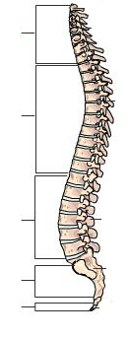

Label the features of the synovial joint on the diagram below

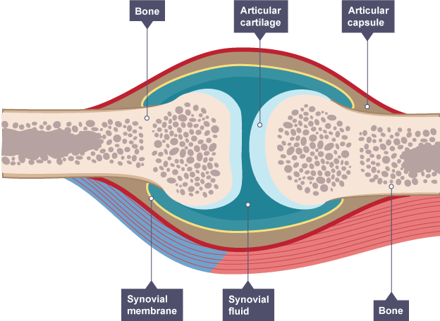

**MUSCULAR SYSTEM**

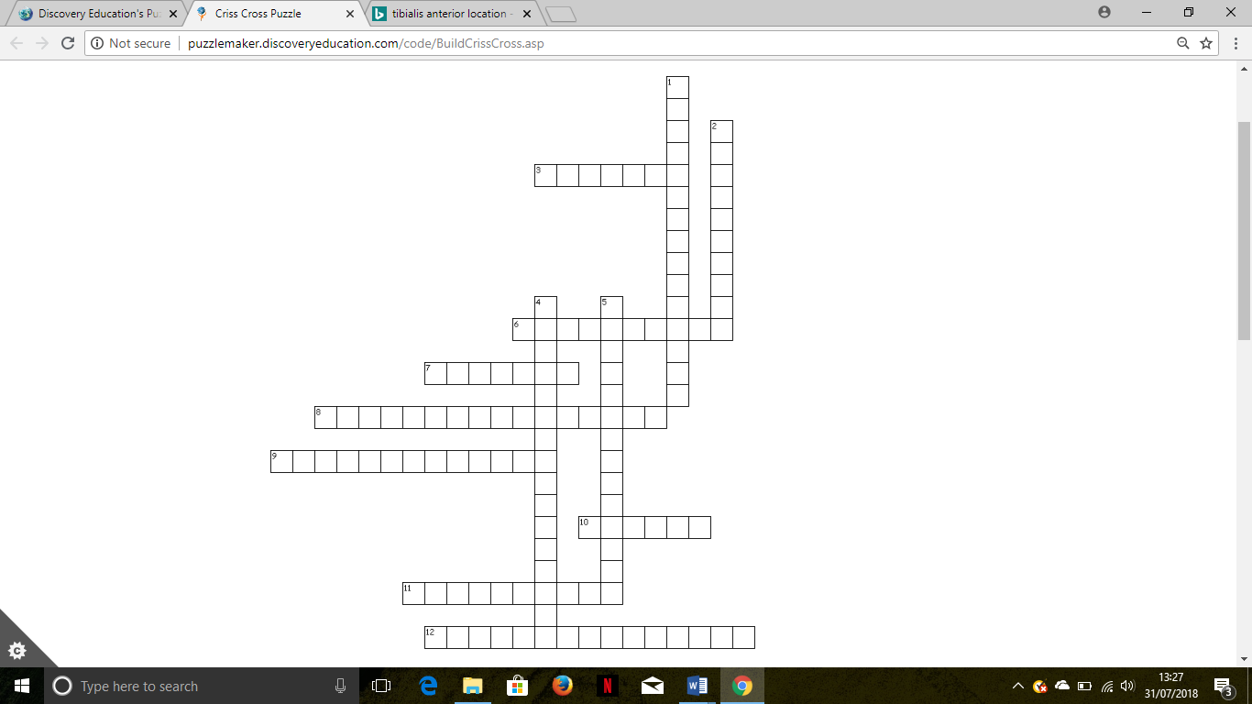**Task –** complete the crossword using the clues.

|  |  |
| --- | --- |
| Across | Down |
| 3. A muscle found at the back of the arm  6. Are located at the front of the hip joint and thigh  7. Is a muscle found at the shoulder  8. Is a group of muscles located at the side of the abdominal muscles  9. Is a muscle found at the back of the lower leg  10. A muscle found at the front of the arm  11. A group of muscles found at the back of the upper leg  12. A muscle found in the chest | 1. A large muscle located in the upper back  2. A group of muscles found at the front of the upper leg  4. Is located in the front of the lower leg  5. Is located in the buttocks |

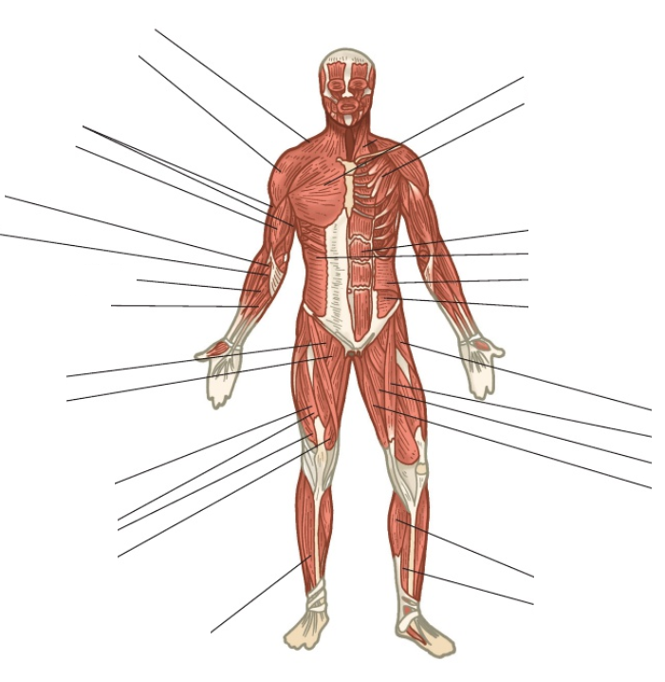**Label the diagram**

|  |  |  |
| --- | --- | --- |
|  | | **Complete** |
| **Major Skeletal Muscles:** | Deltoids |  |
| Biceps |  |
| Triceps |  |
| Wrist Flexors |  |
| Wrist Extensors |  |
| Supinators |  |
| Pronators |  |
| Pectorals |  |
| Abdominals |  |
| Obliques |  |
| Quadriceps |  |
| Hip Flexors |  |
| Tibialis Anterior |  |
| Erector Spinae |  |
| Trapezius |  |
| Quadriceps |  |
| Hip |  |
| Latissimus Dorsi |  |
| Gluteals |  |
| Hamstrings |  |
| Gastrocnemius |  |
| Soleus |  |

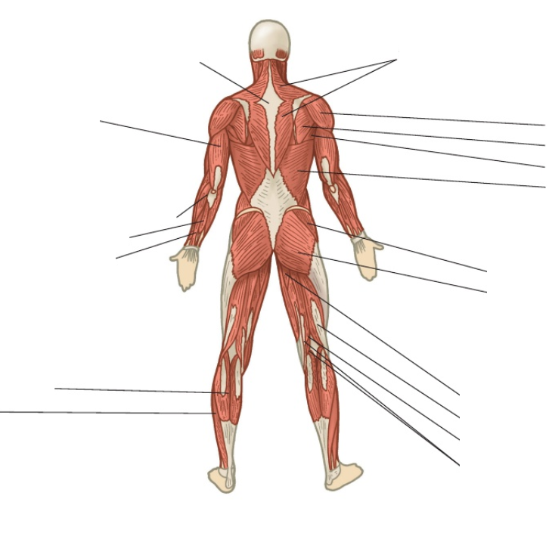

**RESPIRATORY SYSTEM**

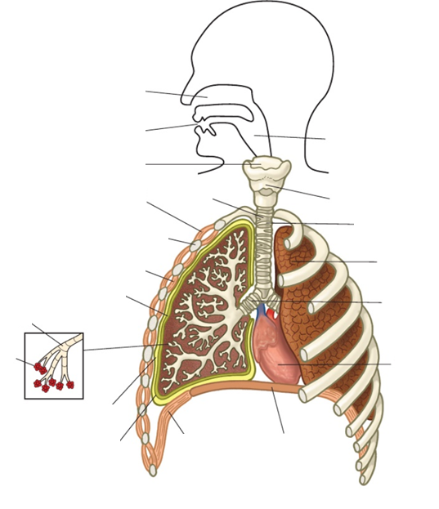

|  |  |  |
| --- | --- | --- |
|  | | **Complete** |
| **Structure:** | Nasal Cavity |  |
| Epiglottis |  |
| Pharynx |  |
| Larynx |  |
| Trachea |  |
| Bronchus |  |
| Bronchioles |  |
| Lungs |  |
| Alveoli |  |
| Diaphragm |  |
| Thoracic Cavity |  |
| Intercostal Muscles (External) |  |
| Intercostal Muscles (Internal) |  |

**CARDIOVASCULAR SYSTEM**

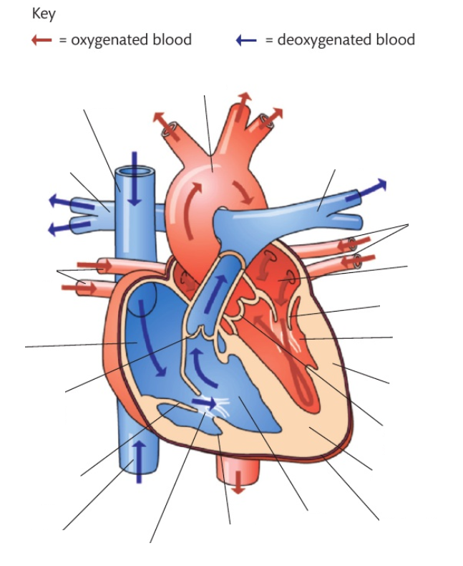

|  |  |  |
| --- | --- | --- |
|  |  | **Complete** |
| **Structure:** | Atria |  |
| Ventricles |  |
| Bicuspid valve |  |
| Tricuspid valve |  |
| Semi-lunar valves |  |
| Septum |  |
| Major blood vessels:   * Aorta * Vena cava * Pulmonary artery * Pulmonary vein |  |
| Coronary arteries |  |
| Structure of blood vessels:   * Arteries * Arterioles * Veins * Venuoles * Capillaries |  |

Can you explain how blood flows through the heart?

Ensure you use the following words: Oxygenated Blood, Deoxygenated blood, Pulmonary artery, Pulmonary Vein, Left Atrium, Right Atrium, Left Ventricle, Right Ventricle, Bicuspid Valve, Tricuspid Valve, Semi-lunar valve (Aortic and Pulmonary), Aorta, Vena Cava.

________________________________________________________________________________________________________________________________________________________________________________________________________________________________________________________________________________________________________________________________________________________________________________________________________________________________________________________________________________________________________________________________________________________________________________________________________________________________________________________________________________________________________________________________________________________________________________________________________________________________________________________________________________________________________________________________________________________________________________________________________________________________________________________________________________________________________________________________________________________________________________________________________________________________________________________________________________________________________________________________________________________________________________________________________________________________________________________________________________________________________________________________________________________________________________________________________________________________________________________________________________________________________________________________________________________________________________________________________________________________________________________________________________________________________________________________