BTEC Level 3 National in Art & Design
Summer Project 2020
Personal Task

During your GCSE Art and Design coursework and exam, you were given a word or theme to respond to. For this project the theme is ‘Personal to me’.
This is purposefully vague in order to make you think hard about what you truly care about. If you artwork has a message and a meaning, then what is it?
We make art because there is something inside the creative person that needs to get out. The poet, musician, actor, and visual artist all have a desire to express what they feel and to create something of great value. It’s a type of therapy or a form of meditation.
You could create work based on something that you love and are deeply passionate about such as your family or a specific charity or cause. It could be about something that you despise and you want to raise awareness about it such as racism, homophobia or sexism. If you care about the environment and protecting forests and animals you use that as your starting point. You might care about how we use plastic and the effect on the oceans and sea life. You may want to tell a story with your artwork; you could tell the story of your family history, culture, childhood, greatest achievements, specific moments in your life, etc.
You could create work relating to current movements or news events.
For example, Black Lives Matter and the protests around the world, the changes which will go down in history as monuments honouring slave traders are brought down and defaced. It could be based on the coronavirus pandemic and the effect of lockdown on people. How it has changed peoples’ lives, how we have celebrated the NHS, how we showed support through rainbows on windows and clapping in the streets. You could focus on the positive aspects such as more family time or the wonders of the internet for keeping in touch. You could explore the negative effects of lockdown on peoples’ mental health, the rise in domestic abuse cases, or not being able to see family outside of your household.
It is your responsibility to find something that is personal to you that will act a starting point for this project; that you feel comfortable exploring and communicating about and can yield enough work and creative ideas to complete this project.

What is expected?
You are expected to produce a minimum of 4 A3 pieces of developmental work and one final piece which is an outcome for the journey of your work.
The A3 pieces of work will reflect assessment objectives 1, 2 and 3 whilst the final piece will reflect assessment objective 4.
You should be familiar with the GCSE assessment objectives from KS4.
- AO1: Develop ideas through investigations, demonstrating critical understanding of sources (artist research/art movements/sources from the wider world that have inspired you)
- AO2: Refine work by exploring ideas, selecting and experimenting with appropriate media, materials, techniques and processes (experiments, exploring, design ideas, planning and samples)
- AO3: Record ideas, observations and insights relevant to intentions as work progresses (observational drawing and initial ideas, photographs and sketches)
- AO4: Present a personal and meaningful response that realises intentions and demonstrates understanding of visual language (final piece or body of work)

Therefore you should create the following A3 sheets:
- A mind map outlining your theme which includes photographs, observational drawings and initial ideas (AO3)
- An artist research page showing TWO artists/sources that have inspired you which links to your theme in some way. The link might be that the artist/designer create work with a similar theme or using a technique that you plan to use. It could simply be that you are passionate about the artists and want to use their style, colour choices, subject matter, media, etc. in some way. It is your responsibility to research artists/critical sources that are personal to you and will inspire you on your creative journey (AO1)
- A sheet of at least 3 design ideas for a final outcome. At this stage these can be very basic sketches to illustrate your ideas. The ideas should be annotated with materials, colour, size and purpose. Why have you thought of this idea, how does it relate to your starting point, how has it been inspired by artist research? (AO2)
- A more detailed and comprehensive plan of your final idea including experimental work. Decide on which design idea you want to create as your final piece and then experiment and further explore it. Think about different colour schemes, scale, orientation, materials, etc. Show your experimentation on this sheet.

Once you have completed these 4 design sheets you must then create your final outcome. Unlike Year 11 this does not have to be a 10 hour piece in exam conditions. Allocate yourself 3 hours to create your final outcome which should be the culmination of all of your research, developmental and experimental work.
These examples are from a variety of projects but should show what is expected from each sheet.
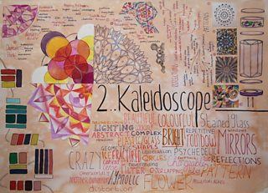
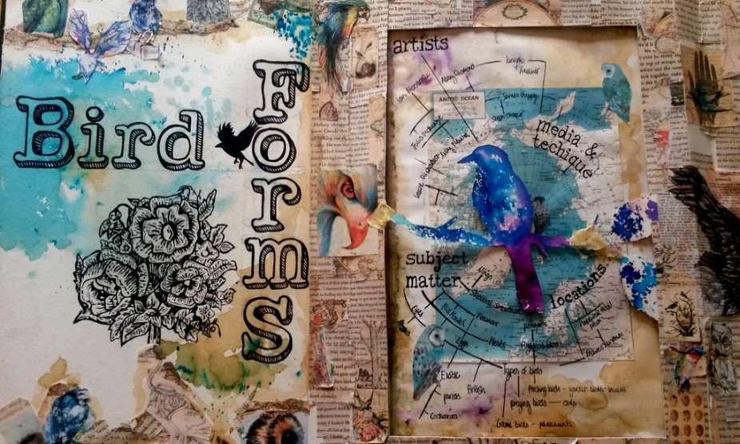
Sheet 1 – Sets the theme, variety of drawings and ideas all linking to the topic.
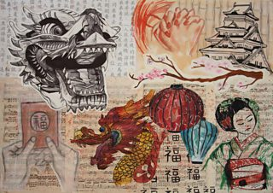

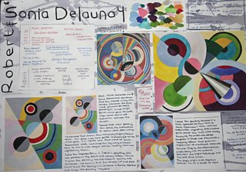
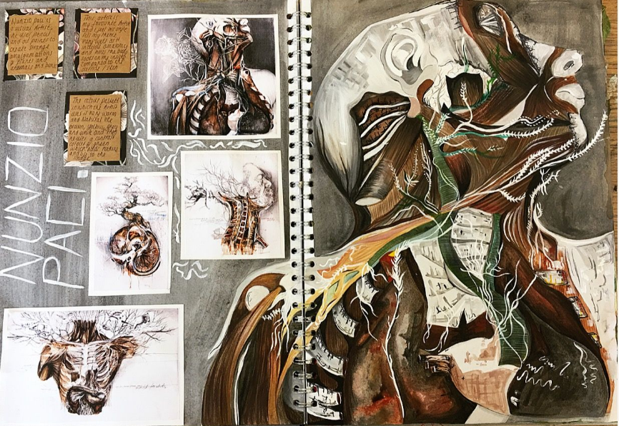
Sheet 2 – Artist research. Includes colour images, designed title, work is in the style of the artist, information and opinions on the work.
Sheet 3 – Variety of design ideas, not limited to one outcome, simple drawings to illustrate ideas.
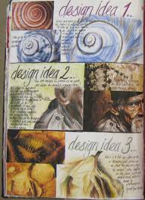
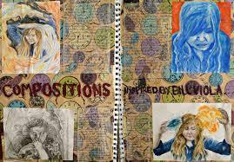
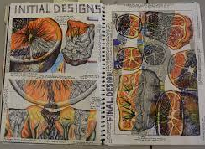

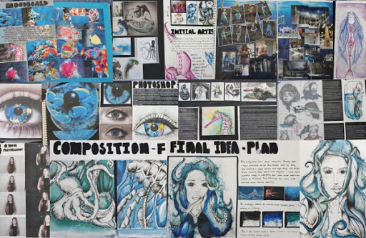
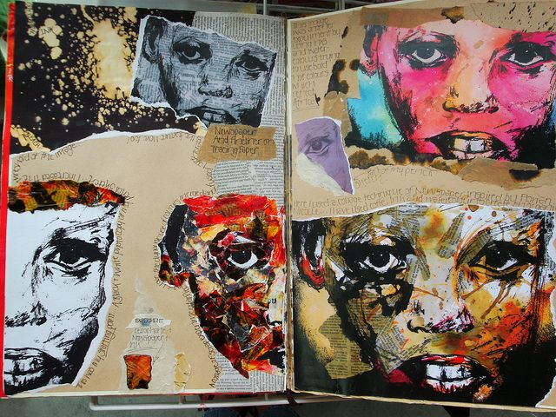
Sheet 4 – Final idea with experiments and annotation

Final outcome – your decision on scale, media, materials, etc.
The work that you create for this project will help you to prepare for Year 12 and may be used as part of your portfolio so please ensure that you try your best and produce something meaningful and personal.
Should you need to contact the art department over summer, the email addresses are:
D.Graham@hollylodge.liverpool.sch.uk
S.Williams@hollylodge.liverpool.sch.uk

Here is a list of websites to find artists/designers to help you with your research:
https://www.tate.org.uk/art/artists/a-z
https://theinspirationgrid.com/category/illustration/
https://contemporaryartfairs.co.uk/artists-a-z/
http://www.creativesketchbook.co.uk/

Here is a list of artists that you might find interesting and might help guide your own research:
Vincent Van Gogh
Paul Klee
Ton Schulten
Tracey Emin
Jean Michel Basquiat
Willem de Kooning
Francis Bacon
Luo Zhongli
George Condo
Wassily Kandinksy
Damien Hirst
Keith Haring
David Hockney
Andy Warhol
Henri Matisse
Edvard Munch
Jackson Pollock
Rene Magritte
Frida Kahlo
Yayoi Kusama.

