Moving to Year 7

Draw a picture of your new school here

Starting a new school is like going on an exciting adventure

Enjoy your journey wherever it takes you!

Name:

Introduction

Starting a new school can be a very exciting time but sometimes you might feel a little bit sad or even worried. Try not to worry about anything as staff will always be there to help you. Before you start at your new school, use the school website to help you to try and complete all the tasks in this booklet. You will probably have lots of questions that you would like to ask about your new school too.
Write down any questions that you have about secondary school on this page.

My Questions

Tick the questions when you have found out the answer.

Facts about your new school

What is the name of the new school that you are going to?
………………………………………………………………………………………………………………………………………..

The name of the Head Teacher is
……………………………………………………………………………………………………………………………………..

The school address is
………………………………………………………………………………………………....................................................................................................................................................................................
………………………………………………………………………………………………………………………………..……

The school telephone number is

……………………………………………………….………..

How many children are at the school?
……………………………………………………………….

At the beginning of Year 7 you will find out which class you will be in. It may be called your form, registration or tutor group rather than your class.

Who is your form tutor?
……………………………………………………………………………………………………………………………………….

Who is your Year Leader?
……………………………………………………………………………………………………………………………………

My School Badge
Draw the school badge in the space below. Write down our mission statement below the badge.

Mission Statement: …………………………………………………………………………………………………
………………………………………………………………………………………………………………………………………………

Same or different?

Many of the things you do in your new school will be very similar to your primary school, but some things might be slightly different.

Write down 5 important things that will be different in your new school.

WORD CLUES TO HELP YOU THINK OF IDEAS:
Lunch time, break time, teachers, friends, lessons, homework, desks, uniform, rooms, timetable, rules, assemblies,

School Uniform

In the space below, make a list of all of the items of school uniform you will need. Can you draw or add a picture of what it will look like?

1………………………………………………………………………………………………………………………………………

2 ……………………………………………………………………………………………………………………………………

3 ……………………………………………………………………………………………………………………………………

4 ……………………………………………………………………………………………………………………………………

5 ………………………………………………………………………………………………………………………………….

6 ………………………………………………………………………………………………………………………………….

The School Day.

You will have 5 lessons and either form time or assembly each day.

Registration starts at……………………………………..

Lesson One is ……………… to …………………

Break time is ……………… to ……………….

Lesson Two is……………… to …………………

Lesson Three is ……………… to …………………

Lunch time is ……………… to …………………

Lesson Four is ……………… to …………………

Lesson Five is ……………… to …………………

Home time is …………………..

What day will assembly be on for year 7?
………………………………………………………………………………………………………………………………………………………………………………………………………………………………………………………………………………………………

In the Classroom
Draw or list all the equipment that you will need to take to school each day in the schoolbag below.

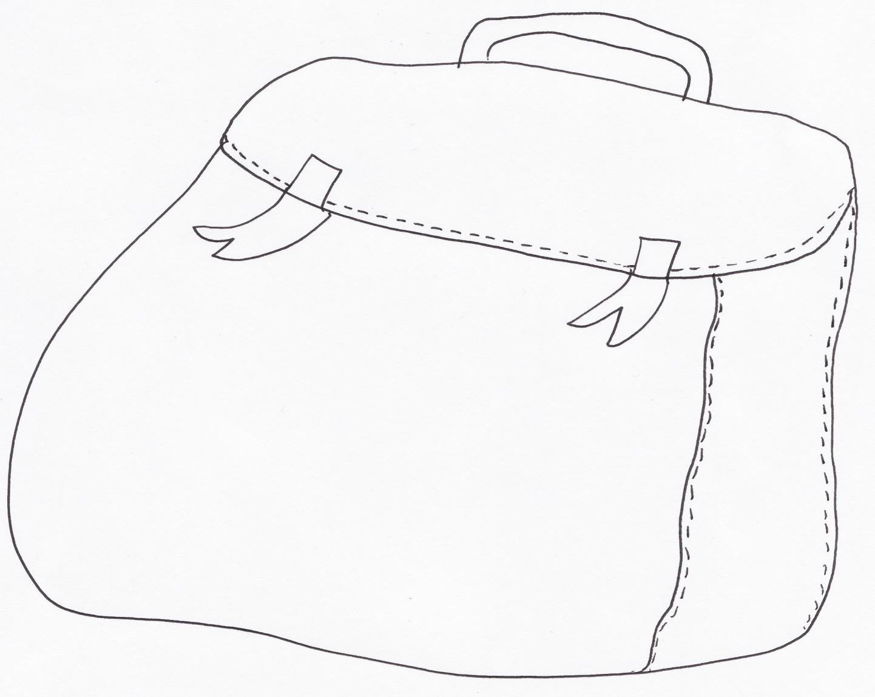

Staff

Write down the names of some of the important staff you will need to know.
(HINT: Year Leader, Mentors, Head Teacher)

Friends

Adults will help you to make new friends. Don’t worry if you feel a bit nervous at first, you will soon get to know everyone.

What sort of things could you say to start making new friends? Write ideas in the 3 speech bubbles below.

Remember try to smile and ask friendly questions.

Use this page to record any questions you may have for your:

Form tutor

Year Leader

Other

Homework

You will get some homework every week. Don’t worry though because your teachers will tell you what the homework is. You will have a log in for Show My Homework, where your teachers will set this work.

Getting to school and home again

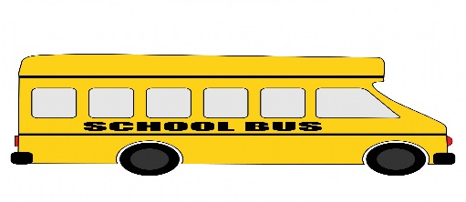

This is often a big worry at first but it will be OK because there will be people to look after you and you will soon get used to it.

How will you travel to your new school?
Cross out the ones you will not do. Tick the ones you may try.

walk cycle car minibus bus taxi train scooter

Knowing the way to school

Use an internet map site to find directions of your route from home to school and stick them in this booklet. You can do this with your parents.

You might want to take some photos / draw some pictures of any land marks that you walk or drive past on the way and stick them in order on this page when you practice getting to school.

Completion Certificate

awarded to

…………………………………….
Congratulations on completing this booklet

You are now an expert on your new secondary school and we hope that you enjoy it!

Signed……………… Date………

