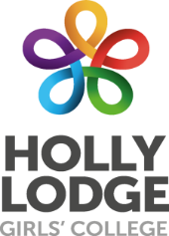
Am I ready for my first day?
Checklist
By 17th July have you……
Watched/read through: | Tick
Visited the Holly Lodge website to learn about your new school
Watched the Holly Lodge transition video
Watched your form tutor’s welcome video
Read the letter from Mr Keen (Headteacher)
Completed some transition work (optional)
Read through the ‘Who am I’ information packs
Completed your ‘who am I booklet’ and returned it to school
Had an introduction phone call with your form tutor

By 19th August have you…..
Read through: | Tick
The welcome pack sent, completing the student personal information page and returning it to Holly Lodge
The information about the school day/term dates
The information on Free School Meals and applied if applicable
Signed up to ParentPay
The information on the cashless catering system
The information on uniform requirements and purchased appropriate uniform and equipment
Completed some transition work (optional)
Completed your Summer reading challenge

The night before/morning of make sure you have……..
Items to check: | Tick
Uniform – Blazer, skirt/pinafore/trousers, white shirt, cardigan/jumper, tie.
Black shoes (no distinctive markings)
Black Coat
Hair Tied back/no jewellery/no make up
PE kit and a pair of trainers
Plain bag big enough to fit an A4 exercise book in and PE kit
Pencil case & stationery – Red Pen, black pen, pencil, ruler, rubber, pencil sharpener & calculator
Remembered who your form teacher is

We are looking forward to seeing you on Wednesday 2nd September 2020!!

