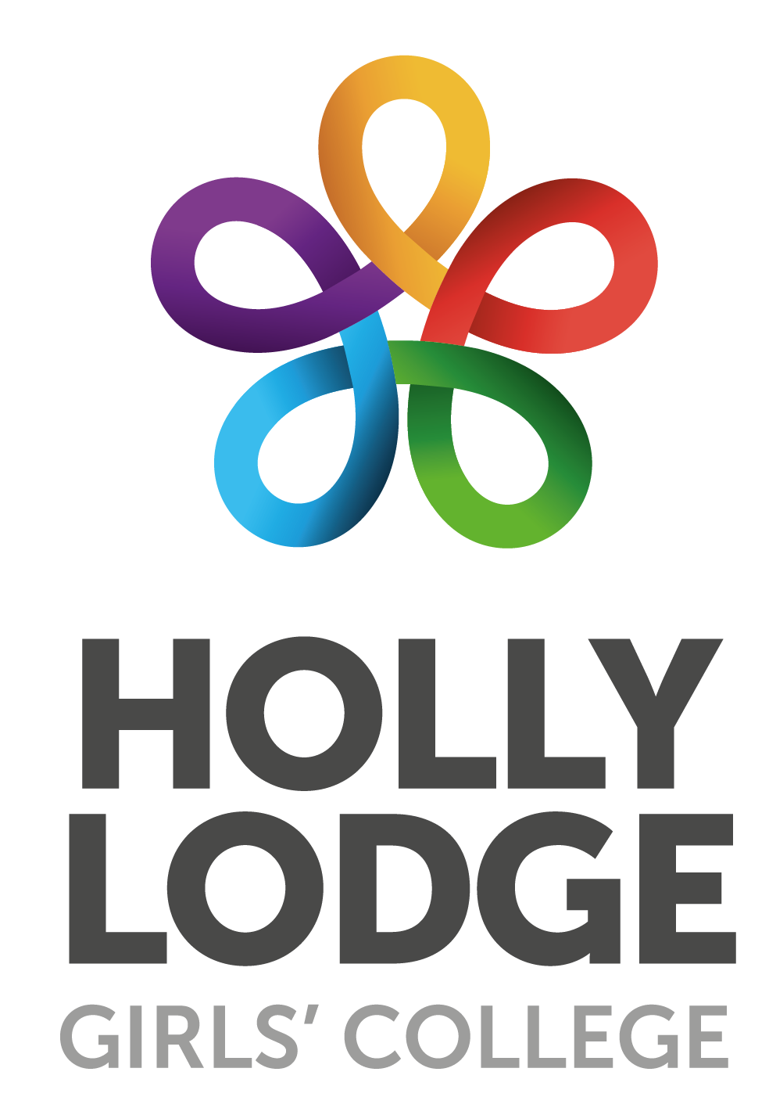
Coronavirus Update – 14/3/20
We continue to follow the advice given to us by local and central government.

Liverpool City Council has set up some social media accounts to give everyone access to the latest information;

Twitter - @covidliverpool Facebook - /covidliverpool

The latest update from the department for Education is shown below;

Department for Education

Department for Education Coronavirus helpline
Today, we have launched a new helpline to answer questions about COVID-19 related to education. Staff, parents and young people can contact the helpline as follows:
Phone: 0800 046 8687
Email: DfE.coronavirushelpline@education.gov.uk
Opening hours: 8am to 6pm (Monday to Friday)
No school should close in response to a suspected (or confirmed) COVID-19 case unless directed to do so by Public Health England.
The government is publishing regular updates and advice concerning Coronavirus. As a school, we will continue to follow the advice given to us by local and central government. Sources of advice for the public are shown below;

Public Health England Information

NHS Information

These are currently being updated on a daily basis, usually at 2pm.

Easter Ski Trip to Italy
We have cancelled our ski trip to Italy. Many thanks to the parents for their support and patience and a big thank you to Miss Hember and Miss Garcia for organising the trip and managing all the issues caused by the Coronavirus pandemic.

General Prevention
Advice from the NHS centre around the need for hand hygiene as follows;
- cover your mouth and nose with a tissue or your sleeve (not your hands) when you cough or sneeze
- put used tissues in the bin immediately
- wash your hands with soap and water often – use hand sanitiser gel if soap and water are not available

In addition, since half term we have adopted a more robust cleaning regime around school focusing on using anitibacterial cleaners on all surfaces.

Please ensure that you follow the advice and instructions contained in the links above.

The importance of hygiene
Personal hygiene is the most important way we can tackle COVID-19. Please help us in sharing simple and effective hand hygiene messages.

Public Health England has a dedicated webpage with a range of posters and digital materials at:
https://campaignresources.phe.gov.uk/resources/campaigns/101-coronavirus-/resources

Sign up is quick, free and means you will be alerted as more resources are made available.

