My score:

Developing | 0-3
Secure | 4-7
Extending | 8-11

Name:
Form:
Submission date:

Sequences homework

1. The nth term of a number sequence is 4n + 5
Work out the first three terms of this number sequence.

............ ............ ............
(2)
2. Here are the first five terms of a number sequence.
3 7 11 15 19
(a) Work out the 8th term of the number sequence.
.........................................
(1)

(b) Write down an expression, in terms of n, for the nth term of the number sequence.

.........................................
(2)
3. The first even number is 2.
(a) Write down the 3rd even number.
...........................
(1)
Here are some patterns made from sticks.
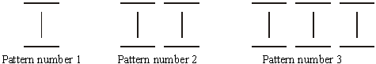
(b) Complete Pattern number 4.
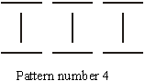
(1)

(c) Complete the table.

Pattern number | 1 | 2 | 3 | 4 | 5
Number of sticks | 3 | 6 | 9

(2)

Jenny wants to find the number of sticks in Pattern number 100.
(d) Write down a method she could use.
.........................................................................................................................
.........................................................................................................................
(1)

4. Here is a number sequence:
2, 5, 10, 17, 26, …

(a) Write the next term in this number sequence ………………………….
(1)

